PRESS INFORMATION March 2017
Immediate release
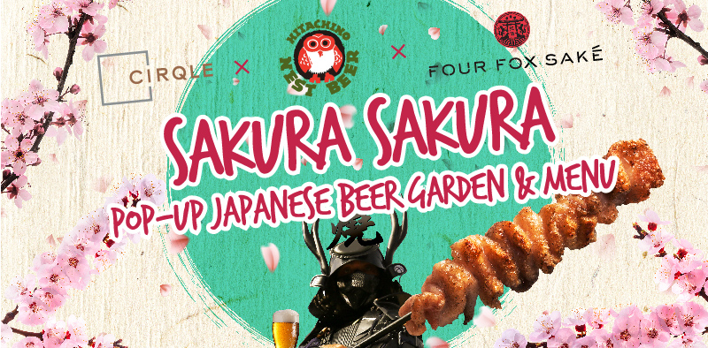
Ovolo Hotels: “Traditional Hotel F&B’s a Thing of the Past!”
Hotel Group Champions Experiential-driven dining in Hong Kong
Hong Kong – Ovolo Hotels is proclaiming the demise of the traditional hotel F&B business in Hong Kong, and focusing on the emergence of concept- & experiential-driven dining. Hotels have traditionally always catered to a very broad demographic – ensuring there was enough options to whet everyone’s appetite. Weekend buffet brunches are a good example of this. Concept- & experiential-driven dining has been taking Hong Kong by storm as of late, with restaurant groups like Black Sheep and Dining Concepts are already leading the pack with their popular spots like La Vache, Maison Libanais, Iron Fairies and Ophelia. Ovolo Hotels, the Hong Kong-born innovative hospitality group, is championing experiential-driven dining in the hotel sector through the launch of its first pop-up concept at Ovolo Southside: Sakura Sakura.

What’s proven to be a huge success for standalone restaurants is still mainly a foreign concept among Hong Kong hotels – that is until now. Kicking off with their Sakura Sakura event, Ovolo aims to show hoteliers and Hong Kong diners alike that hotel’s F&B offering can be more than Club Sandwiches with Fries and Chicken Tikka Masala. The event will witness the transformation of the hotel’s 4th floor venue into a Japanese Hanami Garden-themed wonderland, complete with a range of food items enjoyed by Japanese Cherry Blossom viewers, including:

- Corn on the cop with miso butter
- Chicken Kara-age Sliders with spicy slaw & Katsu Sauce
- Tempura Oysters with wasabi cream & salmon roe
- Black miso cod tacos with pickled daikon, spring onion soy mayo
- Beer & miso marinated pork belly yakitori
- Prawn with Kombu butter & dill and more!

Of course, enjoying these Hanami treats wouldn’t be complete without refreshments! Collaborating with cult-favourite Japanese craft beer brand Hitachino as well as new Sake kid on the block Four Fox Sake, Sakura Sakura will offer a pairing of popular Japanese brews that perfectly compliment the food and scenery. A full-service bar will also be available for the less adventurous yet equally enthused attendees.

Commenting on Sakura Sakura as well as Ovolo’s concept- & experiential-driven goal, Mr. Christian Rasmus, Food & Beverage Manager shares: “Hong Kong has always prided itself on offering world-class dining and amazing hospitality. Niche concepts and experiential dining events have rapidly put the city further at the top of the list for gourmands, both local and international. Ovolo had a great and successful run with CIRQLE at Ovolo Southside, but we realised that the time had come to think bold and move away from this tried & true traditional style hotel F&B offering. Over the next few months, we plan to experiment and run a series of concepts that will welcome different styles of food and overall dining to our Wong Chuk Hang property – we’re also getting rid of the standard in-room dining, and offering unique options such as bento boxes which will coincide with the launch of Sakura Sakura. When you think about it, becoming concept- & experiential-driven fits perfectly with the Ovolo ethos – disruptive, innovative and a whole lot of fun.”

The Sakura Sakura pop-up concept officially runs from 13 March – Mid May 2017. More details are available at: http://www.ovolohotels.com.hk/offers/sakura-sakura/

Sakura Sakura Images + Menus

Ovolo Southside Images
– End –
About Ovolo Hotels
Founded by Girish Jhunjhnuwala in 2002, Ovolo Hotels has become one of Hong Kong’s largest independent owner, operator hospitality firms, by providing business and leisure guests with the best in effortless living. The company keeps in touch with the modern traveller through award winning interior designs, detail-driven comforts, focused all-inclusive service and cutting-edge ensuite technology, all done in Ovolo’s signature style. A proud Hong Kong brand, Ovolo remains a family-owned and privately-operated business with a charitable core. The company now runs four hotels and a service apartment in Hong Kong, and three hotels across Sydney and Melbourne.

More info: www.ovolohotels.com

For more information:
Amadou Doumbia
PR & Communications Manager
+852 2165 1031 amadou@ovologroup.com

